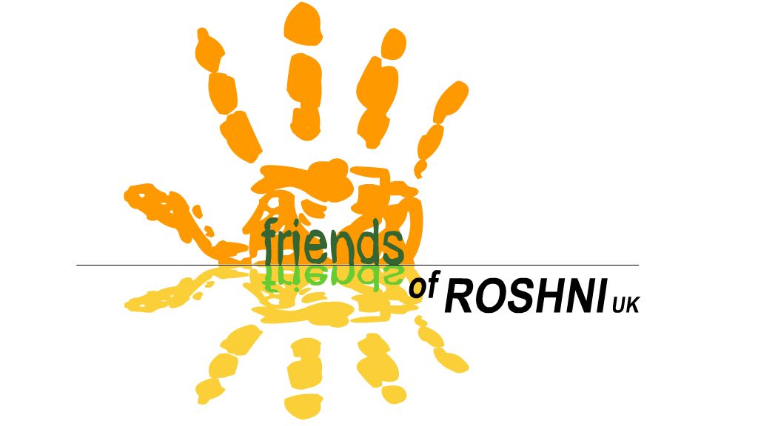
Friends of ROSHNI UK
Registered charity number 1117759

Annual Report 2022

Relating to financial year 1st January – 31st December 2022

This report relates to the following charity:
Friends of ROSHNI UK (FoR)
9 Redland Crescent
Manchester M21 8DL

Objects of the Charity:

- The relief of sickness and the preservation and protection of health for the disabled community in Gwalior, Madhya Pradesh, India, specifically those children and adults with neurological impairments by:
- Providing resources, funding and support for specifically named projects
- Supporting the work of Roshni Ramakrishna Ashrama and its staff and projects
- Other such means as shall be determined by the charity
2. To promote the training and education of staff of Roshni Ramakrishna Ashrama

Charity Trustees during the financial year

The Trustees of Friends of ROSHNI UK are the Committee Members elected at our AGM. All Committee Members are paid-up members of the Charity. All paid-up members are entitled to one vote for each position on the Committee.

The trustees are as follows:

1st January – 5th May 2022:
- Vicki North – Chair  - Vivien Astbury – Vice Chair  - Mick Fox – Treasurer  - Clare Fox – Secretary  - Penny O'Sullivan (Director)  - Susanne Grinham | - Anna Lunn  - Sarah Charnley  - Manjula Patankar  - Mike Lunn  - Bill Quinton

5th May - 31st Dec 2022:

- Vicki North – Chair  - Vivien Astbury – Vice Chair  - Mick Fox – Treasurer  - Clare Fox – Secretary  - Penny O'Sullivan (Director) | - Anna Lunn  - Manjula Patankar  - Mike Lunn  - Bill Quinton

Existing Accountability Procedure for ensuring Friends of ROSHNI UK funds are used as directed by the Committee

At each Managing committee meeting, FoR will allocate funds to ROSHNI.
↓
The funds will be sent to ROSHNI, by registered post
↓
A paper receipt will be expected within 1 calendar month
↓
The FoR committee member based in Gwalior will submit a report for every committee meeting, including updates on projects being supported by FoR
↓
Specific information will be requested as follows:

Child Sponsorship:
An annual report and photo is expected for every child

Small Projects:

For example, training courses, equipment purchase, sponsoring events
A report and receipts/certificates of attendance on training courses must be submitted to the FoR committee on completion of the project

Large projects:

For example, the building project
- Financial & physical progress reports for each committee meeting
- Annual audited accounts and a detailed progress report for AGM

Summary of activities

Membership
Membership Secretary: Clare Fox
Please see attached Membership Secretary’s report.

Child Sponsorship Scheme
Child Sponsorship Coordinator: Penny O’Sullivan
At the end of 2022, 25 children and adults with learning/physical disabilities were being sponsored at Roshni through FoR UK.
Sponsorship fees have been used to support families during the global Covid-19 pandemic, through staff visits/reviews at Roshni, supplementary food parcels, and any other support individual families have needed.

During 2022, FoR sent £7320 to ROSHNI through the Sponsorship Scheme.

We are supported by sponsors donating a full sponsorship of £20 per month, or a Shared Sponsorship, where people can sponsor a child for a minimum of £5 a month, which is combined until the full amount of £20 per month is reached. If an individual isn’t sponsored to a full amount of £20, we cover the difference between the money we raise and the money we send using the Gift Aid which we can reclaim from HMRC on all sponsorship donations. On a full sponsorship, this amounts to £5 Gift Aid.
All our sponsors receive an annual update report with a photo of the student, as well as a roundup of the work of FoR over the year, and a copy of the latest Director’s Annual Report. They also receive our regular e-newsletters.

Fundraising
See Treasurer’s Annual Report

Publicity
Friends of Roshni UK sends our supporters e-newsletters every 1-3 months, with news features about ROSHNI in India, and about our work in the UK. We use the free online template Mail Chimp, which stores our supporters email addresses and helps us meet our GDPR requirements regarding keeping supporters details.
The e-newsletters are written and formatted by the Director. A selection of these are printed and posted to our members who do not have internet access by the secretary.
The FoR UK website continues to be maintained by James Little, and I wish to thank James for his ongoing voluntary support with managing our website.

Volunteers
During 2022, we could not send any volunteers to India due to Covid-19. We hope to resume the programme once it is safe to do so.
We have an appointed Safeguarding Officer (Vicki North) and Deputy Safeguarding Officer (Vivien Astbury). It is their responsibility to review the Safeguarding Policy annually.

Vocational Products
Under HMRC rules, we can sell the items produced by the Vocational Training Group without using formal importation procedures, as the sales further the charity’s aims. A small amount of stock has been sold this year, mainly through sales at events.

FoR UK orders vocational stock from Roshni as we require it, and pay for it straight away rather than as we sell it. This enables Roshni to remunerate the young people more quickly, treats them in a more professional manner, and allows us to manage our stock well. In 2022 we didn’t send any funds over as we had sufficient stock.

Medical/Equipment Funds
Friends of Roshni UK has continued to maintain a Medical Emergency Fund of £100, and an Orthotic Fund of £100 at Roshni. The funds exist to provide emergency or urgent medical care, or essential orthotic appliances to students at Roshni whose families cannot afford to pay for these. There are clear guidelines as to both grants’ use, which we continue to follow.

Both funds are held at Roshni in India. Whenever money is spent from either fund, FoR UK tops it back up to £100, therefore ensuring there will always be money available in a medical emergency or when orthotics are urgently required, without Roshni having to wait for us to send them the money.

Roshni support all their families to apply for a Niryama card, a health insurance scheme run by the Indian Government which people with a registered disability can apply for. This entitles them to free health care. Therefore there has been less need for the medical grant over recent years as more and more families have qualified for this insurance scheme.

During 2022, £75 was sent to top up the Medical Emergency Fund.

Training
£200 was donated to fund staff/parent training at Roshni in 2022.

Service Delivery/Emergency Covid Fund
FoR provided £7641 to help Roshni pay staff salaries over the year. Roshni’s income from within India remains lower than pre-pandemic levels. This is partly due to a loss of fees that families pay for their children to attend Roshni, and partly due to a reduction in donations as families and businesses across the country have had to be more and more careful with their spending. This left Roshni struggling to pay their staff - we were pleased to have been able to continue to support Roshni’s greatest asset - its skilled, dedicated staff team, enabling them to continue supporting our children and their families in whatever way they could.

Parent/Carer Volunteer Grant
This grant exists to reward parent volunteers for their support, as well as reimbursing them the cost of travelling to Roshni each day. There are clear criteria for how volunteers qualify for the grant, including that they should volunteer at least 3 days a week, and have already been volunteering for 6 months. Roshni have to be able to demonstrate how their work is of value to the children/staff.
Due to Covid-19, Roshni was not been able to use their volunteer grant for the previous 2 years, therefore had an outstanding balance. In 2022 they required a top-up of just £100 to provide the grant to 4 volunteers (all mothers).

Building maintenance
FoR UK also provided £535 to settle the balance of the cost of CCTV installation and maintenance, both inside and outside the building. This is now a legal requirement for all school buildings in India, as a safeguarding measure.

To conclude…
It has been heartening and refreshing to hear how Roshni has returned to a more recognisable routine now, with the centre busy and full. However, demand is now exceeding what Roshni can offer, with long waiting lists for the first time in their history - a direct result of the pandemic restrictions endured for over 2 years. We hope that, together, we can continue to help the dedicated and inspiring team at Roshni to meet these new challenges, as well as continuing to offer the high quality, individualised support to those who already depend on them.

Friends of Roshni UK has now existed as an organisation for 18 years, as we held our first official meeting at the start of 2005. We have sent 31 skilled volunteers since our first volunteer went in 2006.

During 2022 we sent a total of £20,000 to Roshni. This means that to date, we have sent £228,844.75 to Roshni.

I wish to once again thank our small but committed group of supporters, who continue to support our fundraising work year after year, as well as new friends and supporters we have made during the year. Congratulations to Manjula and the Roshni team for continuing to aim high, and meet the growing needs of those with neurological disabilities in Gwalior. The need is great, but so is the skill and dedication of the team, both in Gwalior, and here in the UK. Together, we can achieve great things!

Signed: Penny O'Sullivan
Director, Friends of ROSHNI UK
Date: 4th February 2023

