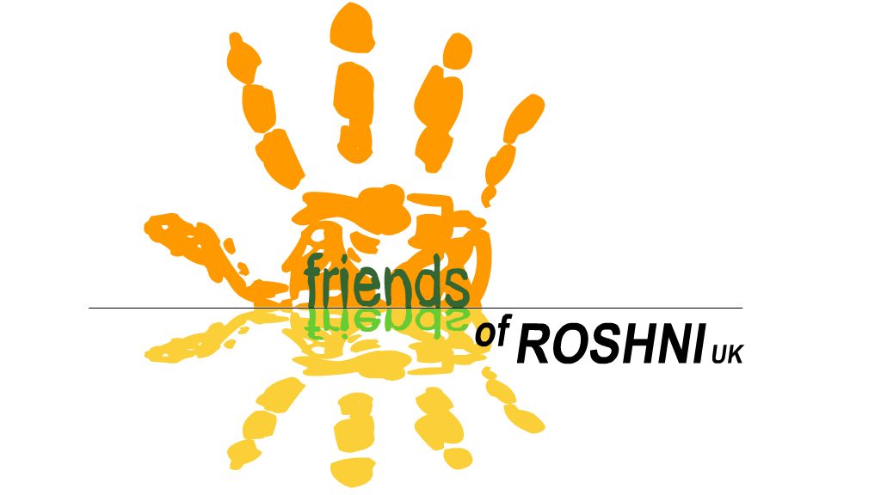
Friends of ROSHNI UK
Registered charity number 1117759

Annual Report 2023

Relating to financial year 1st January – 31st December 2023

This report relates to the following charity:
Friends of ROSHNI UK (FoR)
9 Redland Crescent
Manchester M21 8DL

Objects of the Charity:

- The relief of sickness and the preservation and protection of health for the disabled community in Gwalior, Madhya Pradesh, India, specifically those children and adults with neurological impairments by:
- Providing resources, funding and support for specifically named projects
- Supporting the work of Roshni Ramakrishna Ashrama and its staff and projects
- Other such means as shall be determined by the charity
2. To promote the training and education of staff of Roshni Ramakrishna Ashrama

Charity Trustees during the financial year

The Trustees of Friends of ROSHNI UK are the Committee Members elected at our AGM. All Committee Members are subscribed members of the Charity. All paid-up members are entitled to one vote for each position on the Committee.

The trustees are as follows:

1st January – 7th February 2023

- Vicki North – Chair  - Vivien Astbury – Vice Chair  - Mick Fox – Treasurer  - Clare Fox – Secretary  - Penny O'Sullivan (Director)  - Anna Lunn | - Mike Lunn  - Bill Quinton  Aparna Bhonsle and Manjula Patankar attended committee meetings as co-opted members, representing Roshni in India

7th February - 31st December 2023

- Vivien Astbury - Chair  - Bill Quinton - Vice Chair  - Mick Fox - Treasurer  - Clare Fox - Secretary  - Penny O’Sullivan (Director)  - Anna Lunn  - Mike Lunn | - Vicki North  - Richard Daniels  - Sarah Charnley  Aparna Bhonsle and Manjula Patankar attended committee meetings as co-opted members, representing Roshni in India
Existing Accountability Procedure for ensuring Friends of ROSHNI UK funds are used as directed by the Committee

At each Managing committee meeting, FoR will allocate funds to ROSHNI.
↓
The funds will be sent to ROSHNI, by bank transfer
↓
A donation letter/receipt will be expected within 1 calendar month
↓
Roshni will submit a report for every committee meeting, including updates on projects being supported by FoR
↓
Specific information will be requested as follows:

Child Sponsorship:
An annual report and photo is expected for every child

Small Projects:

For example, training courses, equipment purchase, sponsoring events
A report and receipts/certificates of attendance on training courses must be submitted to the FoR committee on completion of the project

Large projects:

For example, the building project or sensory garden
- Financial & physical progress reports for each committee meeting
- Annual accounts and a detailed progress report for AGM

Summary of activities

Membership
Membership Secretary: Clare Fox
Please see attached Membership Secretary’s report.

Child Sponsorship Scheme
Child Sponsorship Coordinator: Penny O’Sullivan
At the end of 2023, 24 children and adults with learning/physical disabilities were being sponsored at Roshni through FoR UK.
Sponsorship fees are used to fund the provision of education, therapy and support, usually at Roshni, but sometimes through home visits. It may also be used to fund transport to and from school, specialist equipment, medical appointments, food supplements, clothing, educational equipment, or any other individualised support the young person may need.

During 2023, FoR sent £4320 to ROSHNI through the Sponsorship Scheme.

We are supported by sponsors donating a full sponsorship of £20 per month, or a Shared Sponsorship, where people can sponsor a child for a minimum of £5 a month, which is combined until the full amount of £20 per month is reached. If an individual isn’t sponsored to a full amount of £20, we cover the difference between the money we raise and the money we send using the Gift Aid which we can reclaim from HMRC on all sponsorship donations. On a full sponsorship, this amounts to £5 Gift Aid per child, per month.
All our sponsors receive an annual update report with a photo of the student, as well as a roundup of the work of FoR over the year, and a copy of the latest Director’s Annual Report. They also receive our regular e-newsletters.

Fundraising
See Treasurer’s Annual Report

Publicity
Friends of Roshni UK sends our supporters e-newsletters every 1-3 months, with news features about ROSHNI in India, and about our work in the UK. We use the free online template Mail Chimp, which stores our supporters email addresses and helps us meet our GDPR requirements regarding keeping supporters details safe and secure.
The e-newsletters are written and formatted by the Director. A selection of these are printed and posted to our members who do not have internet access by the secretary.
The FoR UK website continues to be maintained by James Little, and I wish to thank James for his ongoing voluntary support with managing our website.

Volunteers
During 2023, we could not send any volunteers to India due to Covid-19. We hope to resume the programme once it is safe to do so.
We have an appointed Safeguarding Officer (Vicki North) and Deputy Safeguarding Officer (Vivien Astbury). It is their responsibility to review the Safeguarding Policy annually.

Vocational Products
Under HMRC rules, we can sell the items produced by the Vocational Training Group without using formal importation procedures, as the sales further the charity’s aims. A small amount of stock has been sold this year, mainly through sales at events.

FoR UK orders vocational stock from Roshni as we require it, and pay for it straight away rather than as we sell it. This enables Roshni to remunerate the young people more quickly, treats them in a more professional manner, and allows us to manage our stock well. In 2023 we sent £80 to Roshni for items sent to the UK to sell here.

Medical/Equipment Funds
Friends of Roshni UK has continued to maintain a Medical Emergency Fund of £100, and an Orthotic Fund of £100 at Roshni. The funds exist to provide emergency or urgent medical care, or essential orthotic appliances to students at Roshni whose families cannot afford to pay for these. There are clear guidelines as to both grants’ use, which we continue to follow.

Both funds are held at Roshni in India. Whenever money is spent from either fund, FoR UK tops it back up to £100, therefore ensuring there will always be money available in a medical emergency or when orthotics are urgently required, without Roshni having to wait for us to send them the money.

Roshni support all their families to apply for a Niryama card, a health insurance scheme run by the Indian Government which people with a registered disability can apply for. This entitles them to free health care. Therefore there has been less need for the medical grant over recent years as more and more families have qualified for this insurance scheme.

During 2023, no funds were required to top up the Medical Emergency/Equipment Fund.

Training
£200 was donated to fund staff/parent training at Roshni in 2023. Please see the report from Roshni to the AGO for full details of expenditure.

Service Delivery
FoR provided £4160 to help Roshni pay for service delivery, including staff salaries over the year. Roshni’s income from within India remains lower than pre-pandemic levels. This is partly due to a loss of fees that families pay for their children to attend Roshni, and partly due to a reduction in donations as families and businesses across the country have had to be more and more careful with their spending. This left Roshni struggling to pay their staff - we were pleased to have been able to continue to support Roshni’s greatest asset - its skilled, dedicated staff team, enabling them to continue supporting our children and their families in whatever way they could.

Parent/Carer Volunteer Grant
This grant exists to reward parent volunteers for their support, as well as reimbursing them the cost of travelling to Roshni each day. There are clear criteria for how volunteers qualify for the grant, including that they should volunteer at least 3 days a week, and have already been volunteering for 6 months. Roshni have to be able to demonstrate how their work is of value to the children/staff.
In 2023, we donated £1000 to provide the grant to 4 volunteers (all mothers).

Building maintenance/sensory garden
No funds were required in 2023

To conclude…

Friends of Roshni UK has now existed as an organisation for 19 years, as we held our first official meeting at the start of 2005. We have sent 31 skilled volunteers since our first volunteer went in 2006.

During 2023 we sent a total of £10,000 to Roshni. This means that to date, we have sent £238,844.75 to Roshni.

2023 was, in part, a year of great celebration for Roshni, as we celebrated the 25th anniversary of its founding.

But it was also a year of deep loss for everyone, with the passing of Manjula Patankar. Manjula had founded Roshni in 1998, with her friend Priti Kapoor, both special needs teachers. Manju worked tirelessly and selflessly throughout those 25 years; right until the end, even as she was struggling with her own deteriorating health and undergoing medical treatment, she continued to oversee the management of Roshni. One benefit the pandemic brought was that we all started meeting remotely, enabling Manju to join us in our meetings. She never lost her drive and enthusiasm.

The legacy she leaves is a city where people with disabilities are included, in schools, in workplaces, sporting events and facilities; travel, leisure and shopping are more accessible. All this is due in no small part to the campaigning and advocacy work the young people of Roshni regularly undertook under her guidance. She empowered the youngsters and their families to campaign for their rights as equal members of their communities. Her legacy enables people with disabilities to access specialist education, therapy and training, and know they are valued when they arrive at their beautiful purpose built school. We had been working together planning the sensory garden - Manjula loved plants and flowers, and had been dreaming of a sensory garden at Roshni right from the start. I am saddened that she won’t see it finished, but I hope that it will be a place where students, staff and friends can sit in peace, and remember her.

Signed: Penny O'Sullivan
Director, Friends of ROSHNI UK
Date: 10th February 2024

