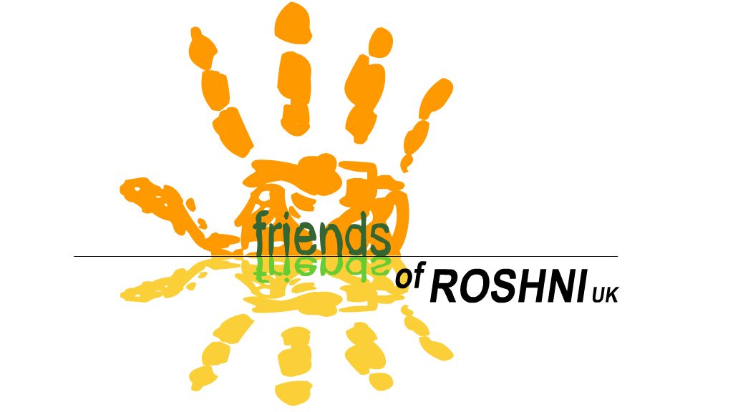
Friends of ROSHNI UK
Registered charity number 1117759

Annual Report 2024

Relating to financial year 1st January – 31st December 2024

This report relates to the following charity:
Friends of ROSHNI UK (FoR)
9 Redland Crescent
Manchester M21 8DL

Objects of the Charity:

- The relief of sickness and the preservation and protection of health for the disabled community in Gwalior, Madhya Pradesh, India, specifically those children and adults with neurological impairments by:
- Providing resources, funding and support for specifically named projects
- Supporting the work of Roshni Ramakrishna Ashrama and its staff and projects
- Other such means as shall be determined by the charity
2. To promote the training and education of staff of Roshni Ramakrishna Ashrama

Charity Trustees during the financial year

The Trustees of Friends of ROSHNI UK are the Committee Members elected at our AGM. All Committee Members are subscribed members of the Charity. All paid-up members are entitled to one vote for each position on the Committee.

The trustees are as follows:

1st January – 13th February 2024
-Vivien Astbury - Chair  -Bill Quinton - Vice Chair  -Mick Fox - Treasurer  -Clare Fox - Secretary | -Penny O’Sullivan (Director)  -Aparna Bhonsle - co-opted member, representing Roshni, India  -Richard Daniels | -Anna Lunn  -Mike Lunn  -Vicki North  -Sarah Charnley

13th February - 31st December 2024

-Vivien Astbury - Chair  -Bill Quinton - Vice Chair  -Mick Fox - Treasurer  -Clare Fox - Secretary | -Penny O’Sullivan (Director)  -Aparna Bhonsle - co-opted member, representing Roshni, India  -Richard Daniels | -Anna Lunn  -Mike Lunn  -Vicki North

Existing Accountability Procedure for ensuring Friends of ROSHNI UK funds are used as directed by the Committee

At each Managing committee meeting, FoR will allocate funds to ROSHNI.
↓
The funds will be sent to ROSHNI, by bank transfer to the Ramakrishna Mission Ashrama FCRA bank account
↓
A donation letter/receipt will be expected within 1 calendar month
↓
Roshni will submit a report for every committee meeting, including updates on projects being supported by FoR
↓
Specific information will be requested as follows:

Child Sponsorship:
An annual report and photo is expected for every child

Small Projects:

For example, training courses, equipment purchase, sponsoring events
A report and receipts/certificates of attendance on training courses must be submitted to the FoR committee on completion of the project. We may request photos of equipment purchased.

Large projects:

For example, the building project or sensory garden
- Financial & physical progress reports for each committee meeting
- Annual accounts and a detailed progress report for AGM

Summary of activities

Membership
Membership Secretary: Clare Fox
Please see attached Membership Secretary’s report.

Child Sponsorship Scheme
Child Sponsorship Coordinator: Penny O’Sullivan
At the end of 2024, 24 children and adults with learning/physical disabilities were being sponsored at Roshni through FoR UK.
Sponsorship fees are used to fund the provision of education, therapy and support, usually at Roshni, but sometimes through home visits. It may also be used to fund transport to and from school, specialist equipment, medical appointments, food supplements, clothing, educational equipment, or any other individualised support the young person may need.

During 2024, FoR sent £7200 to ROSHNI through the Sponsorship Scheme.

We are supported by sponsors donating a full sponsorship of £20 per month, or a Shared Sponsorship, where people can sponsor a child for a minimum of £5 a month, which is combined with other sponsorships until the full amount of £20 per month is reached. If an individual isn’t sponsored to a full amount of £20, we cover the difference between the money we raise and the money we send using the Gift Aid which we can reclaim from HMRC on all sponsorship donations. On a full sponsorship, this amounts to £5 Gift Aid per child, per month.
All our sponsors receive an annual update report with a photo of the student, as well as a roundup of the work of FoR over the year, and a copy of the latest Director’s Annual Report. They also receive our regular e-newsletters.

Fundraising
See Treasurer’s Annual Report

Publicity
Friends of Roshni UK sends our supporters e-newsletters at regular intervals throughout the year, with news features about ROSHNI in India, and about our work in the UK. We use the free online template Mail Chimp, which stores our supporters email addresses and helps us meet our GDPR requirements regarding keeping supporters details safe and secure.
The e-newsletters are written and formatted by the Director. A selection of these are printed and posted to our members who do not have internet access by the secretary.
The FoR UK website continues to be maintained by James Little, and I wish to thank James for his ongoing voluntary support with managing our website.

Volunteers
During 2024, we sent 2 final year student physiotherapists to Gwalior for their elective placements. They are our first volunteers since the Covid-19 pandemic put a stop to international travel and volunteering. Connie Davies and Emily Thompson were a very welcome addition to the team during their 4 week placement, carrying out treatment sessions, training, home visits, and support with hydrotherapy. They were a huge help, and gained valuable experience in neurological and paediatric physiotherapy too. They were welcomed by Aparna, who hosted them at her home during their stay, and all the rest of the Roshni team, many of whom took them out sightseeing or invited them to their homes.
Our Safeguarding Policy is shared with all volunteers/students visiting Roshni. We have an appointed Safeguarding Officer (Vicki North) and Deputy Safeguarding Officer (Vivien Astbury). It is their responsibility to review the Safeguarding Policy annually.

Vocational Products
Under HMRC rules, we can sell the items produced by the Vocational Training Group without using formal importation procedures, as the sales further the charity’s aims. A small amount of stock has been sold this year, mainly through sales at events.

FoR UK orders vocational stock from Roshni as we require it, and pay for it straight away rather than as we sell it. This enables Roshni to remunerate the young people more quickly, treats them in a more professional manner, and allows us to manage our stock well. In 2024 we sent £131 to Roshni for items sent to the UK to sell here.

Medical/Equipment/Transport Fund
Friends of Roshni UK provide a grant of £200. The funds exist to provide emergency or urgent medical care, essential orthotic appliances or equipment, or urgent transport costs to students at Roshni whose families cannot afford to pay for these.

The fund is held at Roshni in India. Whenever money is spent from the fund, FoR UK tops it back up to £200, therefore ensuring there will always be money available when urgently required, without Roshni having to wait for us to send them the money.

Roshni support all their families to apply for a Niryama card, a health insurance scheme run by the Indian Government which people with a registered disability can apply for. This entitles them to free health care. However, not all children/young people qualify for this scheme, therefore may need to access the fund.

During 2024, £200 was donated for the Medical/Equipment/Transport Fund.

Service Delivery
FoR provided £5869 to help Roshni pay for service delivery, including staff salaries over the year. The Indian government has passed a law requiring all organisations that reduced their staff pay during the pandemic (when staff were not coming to work) to reimburse their loss of earnings. This is a legal requirement. Rather than use their limited funds, the FoR committee agreed to support this by donating half the cost of the backpay in 2024.
Roshni’s income from within India remains lower than pre-pandemic levels. This is partly due to a loss of fees that families pay for their children to attend Roshni, and partly due to a reduction in donations as families and businesses across the country have had to be more and more careful with their spending. There has also been a significant increase in the cost of living. The committee are pleased to be able to support Roshni, and our fantastic staff team who do such important work in Gwalior.

Parent/Carer Volunteer Grant
This grant exists to reward parent volunteers for their support, as well as reimbursing them the cost of travelling to Roshni each day. There are clear criteria for how volunteers qualify for the grant, including that they should volunteer at least 3 days a week, and have already been volunteering for 6 months. Roshni have to be able to demonstrate how their work is of value to the children/staff.
In 2024, we didn’t send a donation, as there was money remaining from the previous year due to reduced volunteering (due to the Covid-19 pandemic).

Training grant
In 2024, we didn’t send a donation, as there was money remaining from the previous year due to reduced opportunities for attending or running training courses (due to the Covid-19 pandemic).

Building maintenance/sensory projects
in 2024 we sent:
- £1000 towards building repairs, maintenance and safety
- £1000 towards rainwater harvesting/irrigation system for the sensory garden
- £1000 to purchase an air conditioning unit for the ASD classroom, which includes a significant contribution towards the increased cost of electricity to run the unit
- £1000 towards equipment for the sensory room, and the salary for Manju Solanki, who is working part-time as the Sensory Room coordinator

Grandmothers’ Fund
we sent £500 towards the Grandmothers’ Fund, which is used to provide monthly food.essentials parcels to our most needy families at Roshni. Approximately 12 families benefit from these.

Christmas Treat
As usual, we sent a small donation of £100 to fund a Christmas celebration for the staff and children, a little party with treats for everyone! Roshni closes for 2 weeks over Christmas and New Year, like the UK school holidays, so this always ends the term with a chance to put on their Santa hats and have fun together!

To conclude…

Friends of Roshni UK has now existed as an organisation for 20 years, as we held our first official meeting at the start of 2005. We have sent 33 skilled volunteers and final year students since our first volunteer went in 2006.

During 2024 we sent a total of £18,000 to Roshni. This means that to date, we have sent £256,844.75 to Roshni. This is a significant cause for celebration for us, as we pass the quarter of a million milestone!

2024 marked a time of significant change for us all at Roshni and at Friends of Roshni UK, as we have tried our best to adjust to managing without Manjula Patankar, the co-founder and Director of Roshni. It has been difficult for everyone mourning her loss, whilst also trying to ensure all the work is carried out to a high standard. She was a strong, inspirational person, and worked tirelessly for Roshni. She was involved with all aspects of Roshni’s work, from long term planning and developing projects, to the details of day to day activities with the young people and their families. Her shoes are hard to fill, but her daughter Aparna is doing a fantastic job. She has the support of the Roshni team, practically and emotionally, and I hope they all know they have our support too. We look forward to working with her, Swamiji and the Roshni team in the coming years.

Signed: Penny O'Sullivan
Director, Friends of ROSHNI UK
Date: 7th February 2025

